New Public Procurement Thresholds 2016
The new public procurement thresholds for 2016/17 are shown below (old thresholds in brackets for information). The revised thresholds show a decrease due to fluctuations in exchange rates over the previous two years. These apply from 1st January 2016 and will be in place until the end of 2017.
Public Contracts Regulations 2015 (PCR 2015)
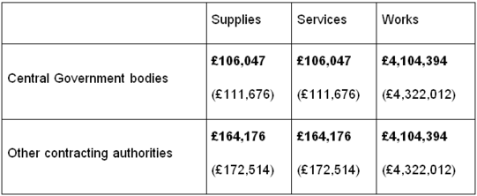
The new threshold for light touch services (social and similar) procured under PCR 2015 is £589,148 – full list of services can be found in Schedule 3 of the Regulations, a link to which is below:- http://www.legislation.gov.uk/uksi/2015/102/pdfs/uksi_20150102_en.pdf

