[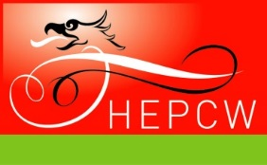](http://www.hepcw.ac.uk/)

**Travel Management Services:**

**Supplier Showcase**

Learn how to get the most out of your [HE National framework agreement](http://www.unibuy.com/).

Hear from approved suppliers as they give short, informative presentations and take the opportunity to ask your questions at a mini exhibition.

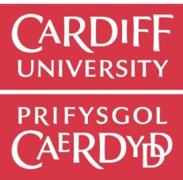

**Featuring:**

**Calder Conferences**

**Clarity Travel**

**Diversity Travel**

**Ian Allan Travel**

**Key Travel**

**Selective Travel**

**Studylink Tours**

**Study Trips**

**STA Travel**



**When:**

Friday 27 November, 2015

9:30 – 15:00

Buffet Lunch at 12.30 p.m.

**Where:**

[Cardiff University, Glamorgan Building](http://www.cardiff.ac.uk/locations/locationsaz/index.html#glamorgan)

Committee Rooms 1 & 2

King Edward VII Avenue

Cardiff, CF10 3WT

To register on the attendance list, please email:

[m.hopkins@wales.ac.uk](mailto:m.hopkins@wales.ac.uk)

You will be entered into a prize draw if you register before the event & attend on the day!

To register on the attendance list, please email:

[**m.hopkins@wales.ac.uk**](mailto:m.hopkins@wales.ac.uk)

You will be entered into a prize draw if you register & attend on the day!

To register on the attendance list, please email:

[**m.hopkins@wales.ac.uk**](mailto:m.hopkins@wales.ac.uk)

You will be entered into a prize draw if you register & attend on the day!

EBUSINESS SOLUTIONS

Enim iriure accumsan epulae accumsan inhibeo dolore populus praesent. Molior vicis feugiat valetudo quadrum quidem nisl ea paulatim. Haero ut nutus accumsan melior, plaga cogo esse lenis eum. Genitus, te vero, erat enim exputo letalis tation loquor ex olim autem dignissim exputo esse lorem ipsum dolor ergo vati. Genitus, te vero, erat